# Day 1 - Verify DNS and Explore SRV Records

**Confirm the zone and that it's AD-integrated**

I need to look for `ad.karabonode.co.za` with `ZoneType: Primary` and `IsDsIntegrated: True`. AD-integrated means the zone data lives in AD itself and replicates automatically with every other DC — that matters directly next week when `dc02` needs to see this same zone the moment it's promoted.

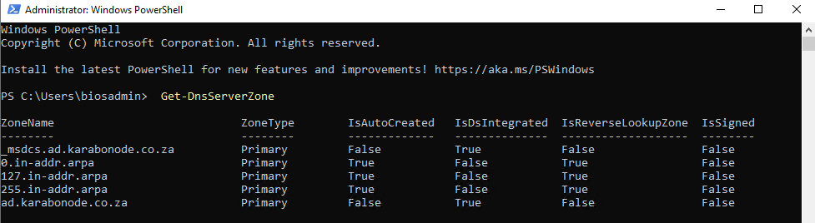
**Open DNS Manager**
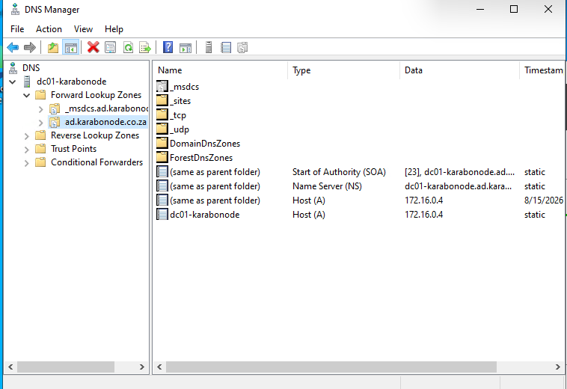
**Find the `_ldap` and `_kerberos` SRV records** inside `_tcp` and note, in your own words, what each is for:

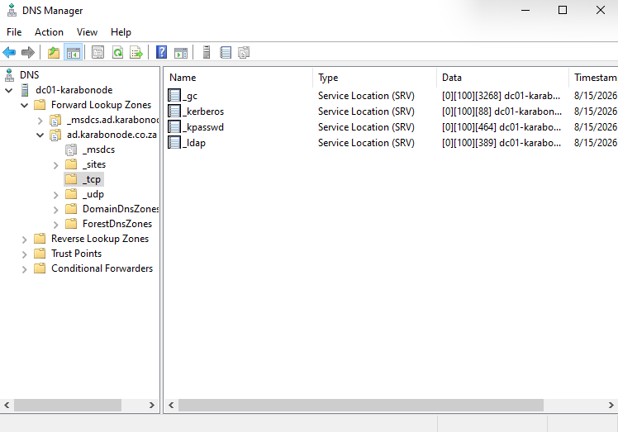

- _ldap (port 389): This file contains information on the location of this domain for any application that needs to communicate with the ad directory services, like finding user information
- Kerebos (port 88): It tells the client if you need the kerebos service for the domain this is where you can find it. This is used for authenticating the user (user-dns-locate ad - domain controller-_kerebos)
- _kpass(port 464) the recird tells the client where they can find the services used to change kerebos related password
- _gc (port 3268): the Global Catalog us a special service provided by the DCs that contains the information about objects across entire forests.

I added the . after ad.karabonode.co.za to tell DNS that this is the complete/absolute domain name, so it should not append anything else to it. I added 172.16.0.4 because that is the IP address of my Domain Controller/DNS server, and I wanted nslookup to specifically query my AD DNS server instead of using the computer's default DNS server.
